

**SCHOOL OF INFORMATICS & IT**

**Part 1: Project Proposal**

Student Name (Matric Number) :

Tutorial Group :

Jenny LING (TP)

Tutor :

Submission Date :

**Declaration of Originality**

I am the originator of this work and I have appropriately acknowledged all other original sources used as my references for this work.

I understand that Plagiarism is the act of taking and using the whole or any part of another person’s work, including work generated by AI, and presenting it as my own.

I understand that Plagiarism is an academic offence

and if I am found to have committed or abetted the offence of plagiarism in relation to this submitted work, disciplinary action will be enforced.

**Declaration on the use of Generative AI tools for assignments**

|  |
| --- |
| Describe how you have used Generative AI tools such as ChatGPT or Dall.E-2 in your assignment.  Show snapshots of the conversations with the AI tool (i.e., the prompts you used and the response you get from the AI tool). |
|  |
| How do you indicate the reference?  The content generated by AI tools are not retrievable except by the user who generated them, so they are considered non-recoverable sources. Although non-recoverable data or quotations in APA Style papers are usually cited as personal communications, with ChatGPT-generated text there is no person communicating. Quoting text from ChatGPT chat is therefore more like sharing the output of an algorithm, with a reference list entry and the corresponding in-text citation.  According to the official APA Style site, ChatGPT references should be cited as:  E.g. OpenAI. (2023). *ChatGPT* (Sep 25 version) [Large language model].  <https://chat.openai.com/chat> |

**Important Note:**

* Do not copy answers produced by the AI tool in totality as it is considered as plagiarism.
* Do not rely on any information produced by the AI tool blindly. You should always verify the answer with other sources. Do not assume that these answers provided by the AI tool are correct.

To achieve quality outputs from the AI tool, you should provide good prompt that is clear and specific. Be precise and provide context. Avoid asking open-ended questions.



School of Informatics & IT

**Mobile App Development (CIT2C18)**

**AY 25/26 Apr Semester**

**Project Proposal**

**(Part 1)**

|  |  |
| --- | --- |
| Name: | XXX |
| Admission Number: | 24XXXXXZ |
| Class: | P0CX |

Table of Contents

Application Description 5

Project Scope 6

Database Design 7

Design Screenshots 8

Widget Tree 9

The yellow text in each section is provided as a guide. Please make sure to REMOVE them before submitting your work.

# Application Description

Include problem statement, application name, target audience and justification of application.

|  |  |
| --- | --- |
| **Problem Statement** | Describe the sustainability-related issue to be addressed or a condition to be improved upon |
| **Application Name** | Provide a name for your application eg. Sustainability Buddy |
| **Target Audience** | Identify your target audience |
| **Solution Justification** | Highlight how the proposed application addresses the issue highlighted in the problem statement |

# Project Scope

State and describe the proposed functions.

**Authentication-related:**

|  |  |  |
| --- | --- | --- |
| **No.** | **Function Name** | **Description** |
| 1. | Login | … |
| 2. |  |  |
| 3. |  |  |

**CRUD related (ONE set ONLY):**

|  |  |  |
| --- | --- | --- |
| **No.** | **Function Name** | **Description** |
| 1. | C: | … |
| 2. | R: | … |
| 3. | U: |  |
| 4. | D: |  |

**Others, if any:**

# Database Design

Include Data dictionary and ER Diagram

Please note the requirements for Part 2, 3 and 4. It is recommended that you have at least one other table (apart from “users” table) to perform the CRUD operations.

**ER Diagram**

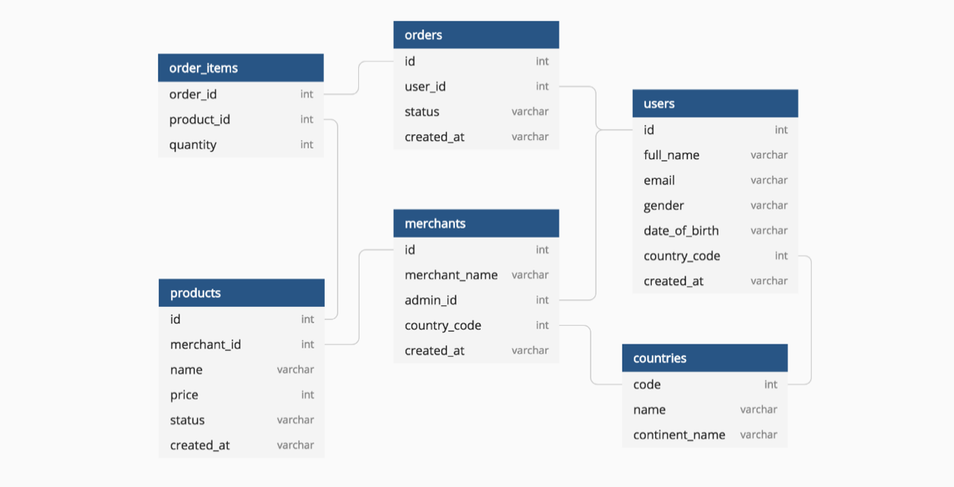

*Suggested Tool: MySQL Workbench or Objects in Microsoft Word*

**Data Dictionary (Table: Products)**

|  |  |  |  |  |  |
| --- | --- | --- | --- | --- | --- |
| **Field Name** | **Data Type** | **Field Size** | **Primary/ Foreign key** | **Description** | **Example** |
| id | Integer | 8 | Primary key | Unique number for product | 10000001 |
| Merchant_id | Integer | 8 | Foreign key | Unique number for merchant | 10000001 |
| Name | Varchar2 | 30 | - | Name of product | Laptop |
| Created at | Date/Time | - | - | Product created date | 14/09/2020  10:12:20 |
| … |  |  |  |  |  |

# Design Analysis and Wireframe

**Generate Design Concepts:**

* Use DALL E to generate images based on your app's concept and user requirements
* You can describe the key elements of your app (e.g., “minimalist social media profile page with vibrant colours and modern typography” or “a clean and intuitive e-commerce product display screen with large images and bold typography”).

**Analyse and Reflect**

Generate a set of at least 3 AI-generated images and design concepts and analyse each design carefully. Consider the following when reflecting on whether a design is suitable:

* Does the design align with your app's target audience and purpose?
* Is the design visually appealing and user-friendly?
* Does the design adhere to UI principles like simplicity, clarity, and accessibility?
* How well do the generated designs complement each other in terms of visual coherence (e.g., colours, fonts, and layout consistency)?

Based on your analysis, choose the most effective and functional designs for your app. You may combine elements from different concepts or modify the designs to better fit your app's needs. Reflect on why you selected specific elements and how they contribute to your app's overall user experience.

**Final Design**

After selecting the best designs, you will further refine them using Figma. This may involve adjusting colours, fonts, and layouts to align with your app's functionality and branding. Provide screenshots for your application design:

* Wireframes (hi-fi).
* Minimum of 5 screens.
  + Authentication related screens are considered as one screen.
  + Modal forms can be considered as separate screen.

Suggested Tool: Figma, Axure (provide clear screenshots)

# Widget Tree

Identify the widgets that you will be using for the body of the main screen and construct the widget tree, for example (widget tree is the diagram on the **extreme right**):

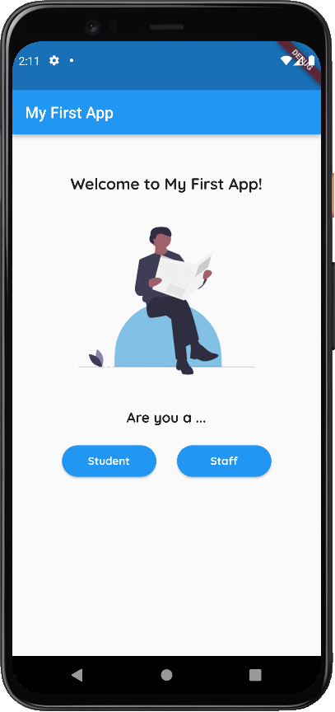

**Column**

**Row**

**Text**

**Image**

**Text**

**Button**

**Button**

**Container**

|  |  |
| --- | --- |
| **Wireframe Screenshot (Main Screen)** | **Widget Tree** |
| <include screenshot> |  |

* + Widget Catalog: <https://docs.flutter.dev/development/ui/widgets>
  + Basic Widgets: <https://docs.flutter.dev/development/ui/widgets/basics>